**Touch**

**Typing**

**Class Five**

**Lab 12**

|  |
| --- |
| Lab Objectives:  * Introducing Capitals * punctuation , . |

# Finger Placement

## You will be able to type a full sentence with a CAPITAL at the start and a full stop (period) at the end.

## There will be nothing to hold you back now

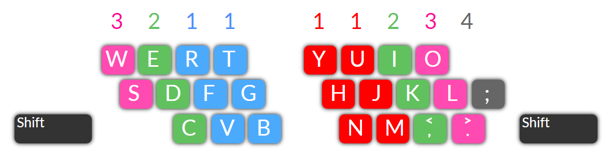

## Use your LEFT HAND RING FINGER (No. 2) to type the letter C, moving your finger down from letter D.

## Use your RIGHT HAND RING FINGER (No. 2) to type the comma , moving your finger down from letter K.

## Use your RIGHT HAND RING FINGER (No. 3) to type the full stop . moving your finger down from letter L.

# Try These Sentences

## CAPITALS - To type Capital letters you will need to use the Shift keys, above the Ctrl keys on each side of the letter key block. Left of Z and Right of ?  The Shift keys are used also for Upper Characters like @ $ % * <

## Press the shift key - Type the letter key - Release the shift key.

## For a Left Hand capital hold the RIGHT Shift key.

## For a Right Hand capital hold the LEFT Shift key

# Experience

## The full stop is on the bottom row. Find the ring finger on your right hand.

## Commas get you thinking, believing. Reach to the left of the full stop. Good.

## Stretch your longest finger. When beginning new lines, hit the Enter key once.

## Find and hold the Right Shift key for these left hand capitals.

## Be careful. Try to keep your fingers curved. Very nice.

## Do not let your wrists rest on the desk. That is not good use of energy.